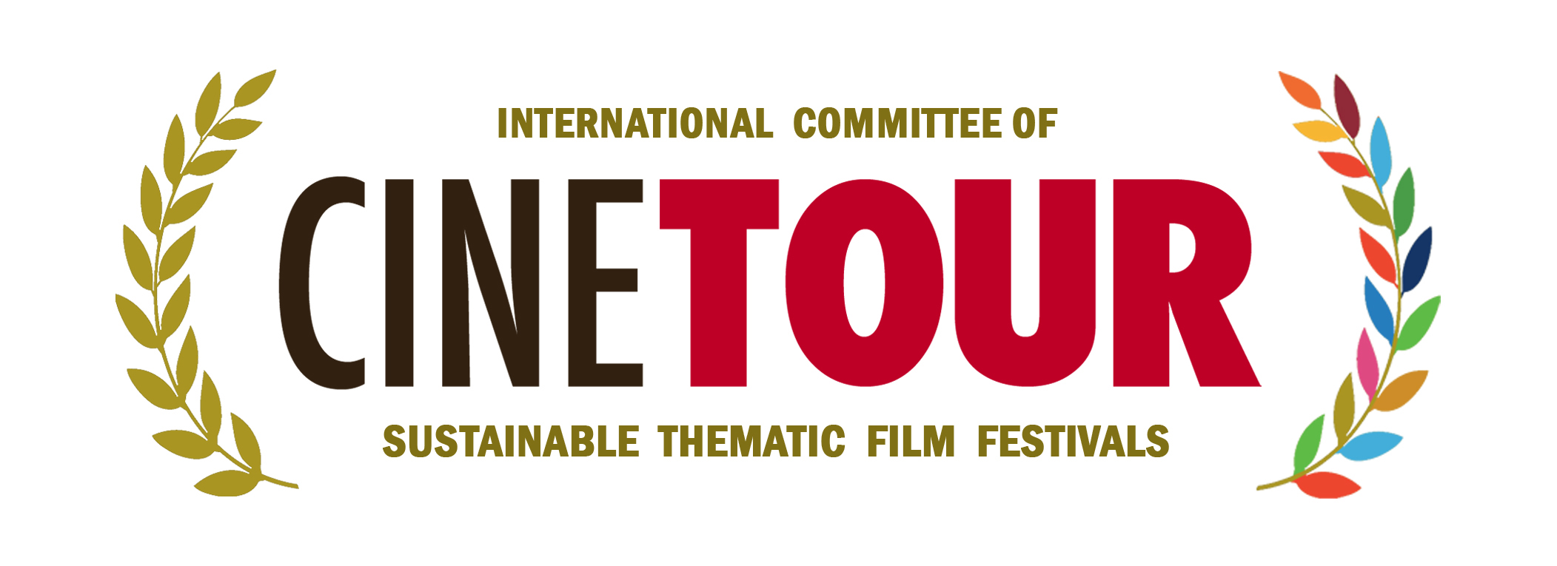

“ PRESS RELEASE ”

CINETOUR
International Committee of Sustainable Thematic Film Festivals

Dear press representatives,

The CINETOUR committee, which aims to gather the world's committed to sustainability most important film festivals under the same roof, has been established. Our press release on the establishment of this important international institution is attached. Since our common sector is media and culture, the support of you, esteemed press organizations, is important to us.

Thank you for your interest in our news.
Best regards.

Can SARAÇOĞLU
President of the CINETOUR

CINETOUR
International Committee of Sustainable Thematic Film Festivals
Phone:+905052967003 /+902164644541 / Palmiye Street No:12/3 Küçükyalı İstanbul / Türkiye
www.cinetour.org / cinetourfest@gmail.com
The world's largest film committee was formed...
With the international meeting held in Istanbul on 24.11.2022, the International Committee of Sustainable Thematic Film Festivals (CINETOUR) was established, open to all member countries of the United Nations, with the support of UNESCO, Foundation for United Nations SDG – FFUN SDG and the Council of Europe. The works were opened with the greeting of the Director of the Council of Europe, Venice office, Mrs. Pavan. The meeting was attended by 30 founding members from 19 member countries. The CINETOUR committee, which aims to bring together thematic film festivals, directors, artists, media-culture-art representatives and many important personalities from the world who make the United Nations AGENDA 2030 their fundamental point, is the first and only committee in the world in this sense.

We have undertaken an important mission...
CINETOUR undertook an important task as the most comprehensive SUSTAINABLE film festivals committee in the world. Today, many festivals are organized with many themes such as culture, art, tourism, sports, health, nature, peace, technology and youth. The number of short film, documentary, animation, commercial, digital arts and feature film festivals is increasing day by day in the world. Quality and strong organizations last for a long time. The main purpose of CINETOUR is to promote, support and bring these festivals together on a common platform. Dialogue and cooperation between festivals will create a sustainable structure. In addition to world-famous festivals, many thematic film festivals also achieve great success. Regionally organized thematic film festivals are also of great importance in the promotion of countries, regions and cities. The synergy that will be created by the coming together of all these festivals will provide an important energy for the culture-art and film industry.

Different cultures, different countries gather under the same roof...
Many festivals organized around the world represent different cultures, different languages and different countries. CINETOUR aims to create a common sound in this multicolor. In this platform where different countries come together, the common language will be culture, art and festivals. All countries will be able to voice their problems, needs and goals. Dialogues between countries will be developed, communication bridges between festivals will be established. Support will be given to the film industry, directors and media. Country managers, powerful institutions and brands will be supported to support the festivals. While benefiting from the experiences of successful festivals for many years, newly established festivals will be supported. International festival calendars will be created. Support will be provided for the resolution of sectoral crises between countries. And an authority will be created where festivals, directors and representatives all over the world can communicate.

We prioritize ethical values enshrined by the United Nations.
While bringing the festivals together, the committee also prioritizes to the core values established by international conventions. These include equality, world peace, intercultural dialogue, women's rights, supporting young people, and developing projects for children. In this context, all members are expected to abide by and implement these rules. In this way, we believe that a sustainable committee will be formed. The CINETOUR committee aims to raise awareness by creating a clear stance in this context.

A new team game begins in the field of film and festival...
One of the main aims of the committee is to ensure that all members have equal rights. This is a team game and each country has important duties. On this platform where different cultures come together, all members work with the same energy and succeed together. There will be no competition, no greed and no distinction between countries. The most important difference of the committee is to develop a common language. Founded with a democratic structure, CINETOUR has a management structure in which every country can have a say. International projects in different branches will be developed with the working groups established within the committee. All member states will be able to jointly develop and implement projects in dialogue. Many international projects will be integrated into the festivals throughout the year and the festivals will be supported. In fact, each project will make a sound on its own. In short, CINETOUR will not only be a platform where festivals meet. At the same time, it will create a constantly developing, project-developing and innovative energy.

The first step is the festival of festivals...
After the establishment of the committee, now it's time for the International CINETOUR Congress. The congress, where film festivals from all over the world apart from all member countries will be invited, will be held in Antalya/Turkey on 8-12 May 2023. In this sense, the inaugural congress will be attended by directors, producers, media representatives, influencers, photographers, artists, sectoral representatives and bureaucrats, apart from thematic film festivals. International film festivals congress, conferences, workshops, workshops, exhibitions, concerts, excursions, fairs and gala ceremony will be held in the organization. The congress, in which world-famous names will attend as guests, creates an important opportunity to identify the problems, needs and solutions of film festivals and the film industry. Special focus will be paid to the UNESCO creative cities network, the European cultural itineraries of the Council of Europe and the new Silk Road project

A snowflake will turn into an avalanche...
Many festivals from Nepal to Los Angeles, from Africa to Asia meet under the same roof, as desired by the United Nations: international partnership and sharing of values. The main goal of the CINETOUR committee, which has reached 30 members during its establishment, is to bring together all festivals with sustainable targets in 2023. Many film festivals around the world are planned short-term and are successful at the local level. Our aim is to support long-term planned festivals. And to ensure that they continue for many years. The main needs of festivals are to find successful films, directors and artists. And the CINETOUR committee creates an important platform that brings them together. In addition, organizational strength is very important for the realization of festivals. Many festivals were held online during the pandemic. And many of them need a budget. The CINETOUR committee will work to provide logistical and organizational support to many festivals. The purpose of festivals should not be just to award films. They need to reach wider audiences by improving their content, especially involving young people. Conferences, exhibitions, workshops, events and social responsibility projects and festivals should be developed. At this stage, CINETOUR will strengthen the sharing between member countries by establishing a communication bridge between countries. And a small regional festival will be able to address the whole world through CINETOUR.

We start with a strong team...
An important task began with the establishment of CINETOUR. With the decisions taken at the founding meeting, Can Saraçoğlu was appointed as the chairman of the CINETOUR Committee. He has significant experience as a director for 25 years and president of international film festivals for 15 years. He took part as a jury in 150 film festivals in 45 countries. Thanks to his strong bond with film festivals and their presidents, he decided to establish this important organization, involving also UNESCO and the Council of Europe. The aegis of these prestigious international institutions makes CINETOUR an entity of global prestige, attracting interest from all over the globe.

Saraçoğlu: I believe in trust, solidarity and team play. We are taking the first step of a sustainable committee. I would like to thank the institutions that support us, all the members and countries who supported me in this important step. We are achieving a first in the whole world. But we have to work hard for it. Film, cinema, media and festivals. They are expectations are high. We will analyze and solve the needs together. We will sign successful projects, organizations and festivals together. Because CINETOUR is a strong team. We welcome new members to CINETOUR. Our only condition is trust and sustainability. We have big goals, but we can achieve them. Soon we will prove it to the world. We will also create an important reference for world peace. Because we have an experienced team. Each of them are successful and important names in their countries. From the ocean coasts in Portugal to the peaks in Nepal. We are ready to support any film festival in the world. We are working to leave a better world for our children and youth.

And the board of the CINETOUR committee includes:

- Can Saraçoğlu / President (Türkiye)

- Maurizio Aronica / General Director (Italy)
- Carlos Sargedas / Director (Portugal)
- Pat Battistini / Director (USA)
- Irina Khangoshvili / Director (Georgia)
- Diana Ashimova / Director (Kazakhstan)
- Anna Kurinnaya / Director (Ukraine)

Founding Members :
- Azer Garib (Azerbaijan)
- Nisha Shrestha (Nepal)
- Darko Basheski (Macedonia)
- Marcello Zeppi (Italy)
- Yerzhan Jumabekov (Kazakhstan)
- Proshoon Rahmaan (Bangladesh)
- Jose Simon Martinez (Spain)
- Mohammed Al-Kindi (Oman)
- Marcello Zeppi (Italy)
- Davide Manganaro (Italy)
- Alessandro Loprieno (Italy)

- Piero Pacchiarotti (Italy)
- Lena Lenzen (Timor-Leste)
- Wolfgang Huschert (Germany)
- Enrique Lepehne (Germany)
- Ginestra Marcucci (Italy)
- Muhammed Rhafrhouf (Morocco)
- Antonio Urano (Brazil)
- Juca Fonseca (Brazil)
- Dalil Belkhoudir (Algeria)
- Jaswant Shrestha (Usa)
- Zbigniew Zmudzki (Poland)

CINETOUR 2022

